Student Name……KESHAV SHARMA………
Student ID:…………4532854……………
Program: Computer programming Course: Network Security and Large Data Solutions
Percentage: 20%
Duration: 2:30 hours (4:00 pm to 6:00 pm)

Requirements
1. The students must be in the class to do the lab
2. Capture the whole screen that shows time and date. Any capture does not include it will have 0 point. Below is an example of the screenshot:
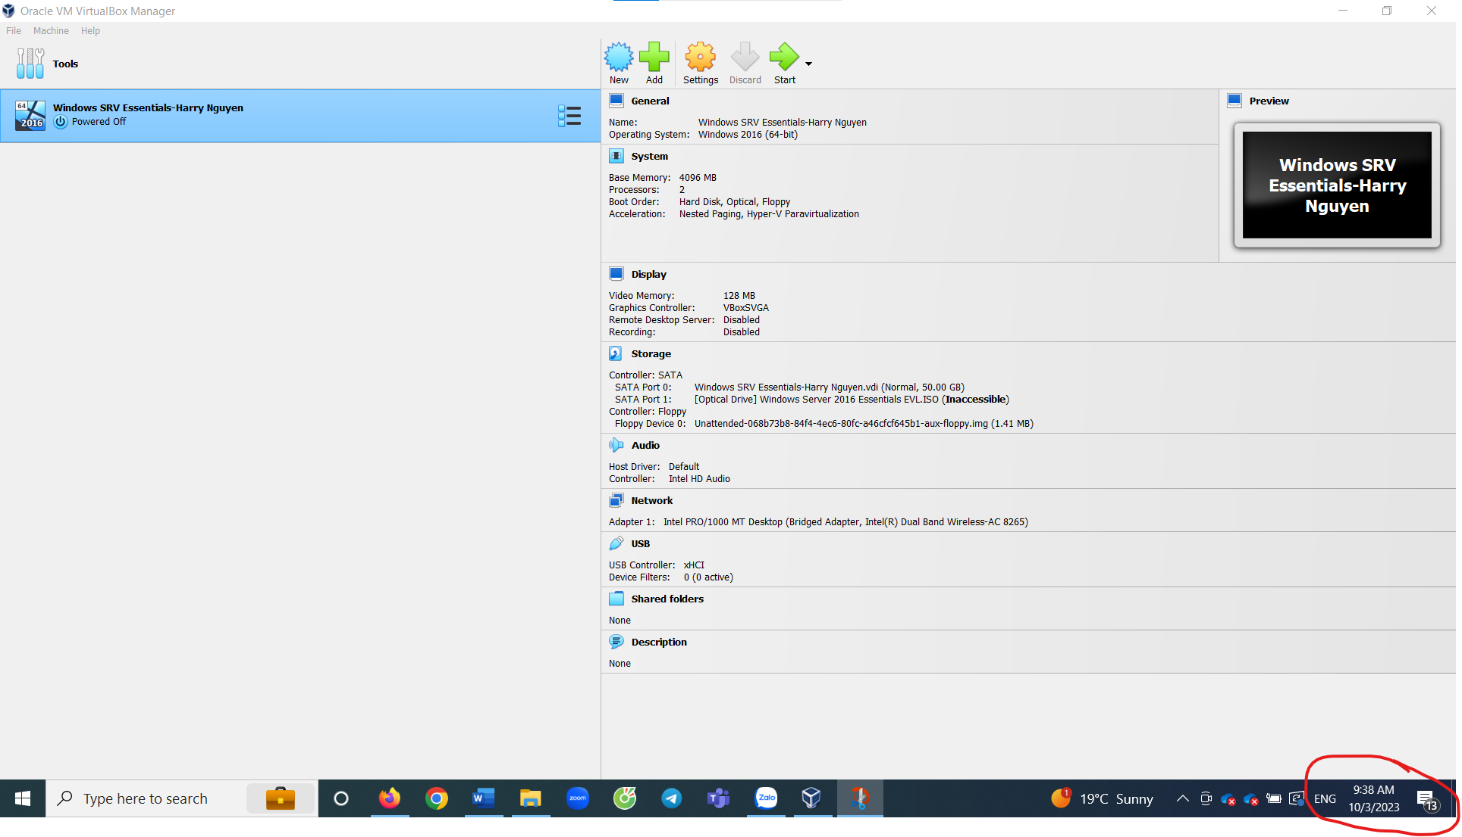
3. There are some screenshots that require your first name and last name. If any of those ones does not have your name, then the whole lab will be 0.
4. When you submit your lab, make sure to include your first and last name in the file name

Important Note
1. The students can follow the instruction step by step to do the lab, however the steps might have minor changes that depend on the version/edition of the software. In such case, students must find out your own steps without asking instructor

Lab 1.1 – Detect phishing sites

Objectives
Part 1: Prepare a VM Windows 10.
Part 2: Perform scanning tool to detect vulnerabilities on Windows 10
Part 3: Reflection question

Required Resources
- A VM for Windows client with a minimum of CPU 1 core, 4 GB of RAM and 12 GB of free disk space.
- VMware Workstation Player, Oracle Virtualbox or any other software that meet NCT policy and your own convenience.

Instructions

Prepare a VM Windows 10, web browser, Internet connection with Netcraft exention
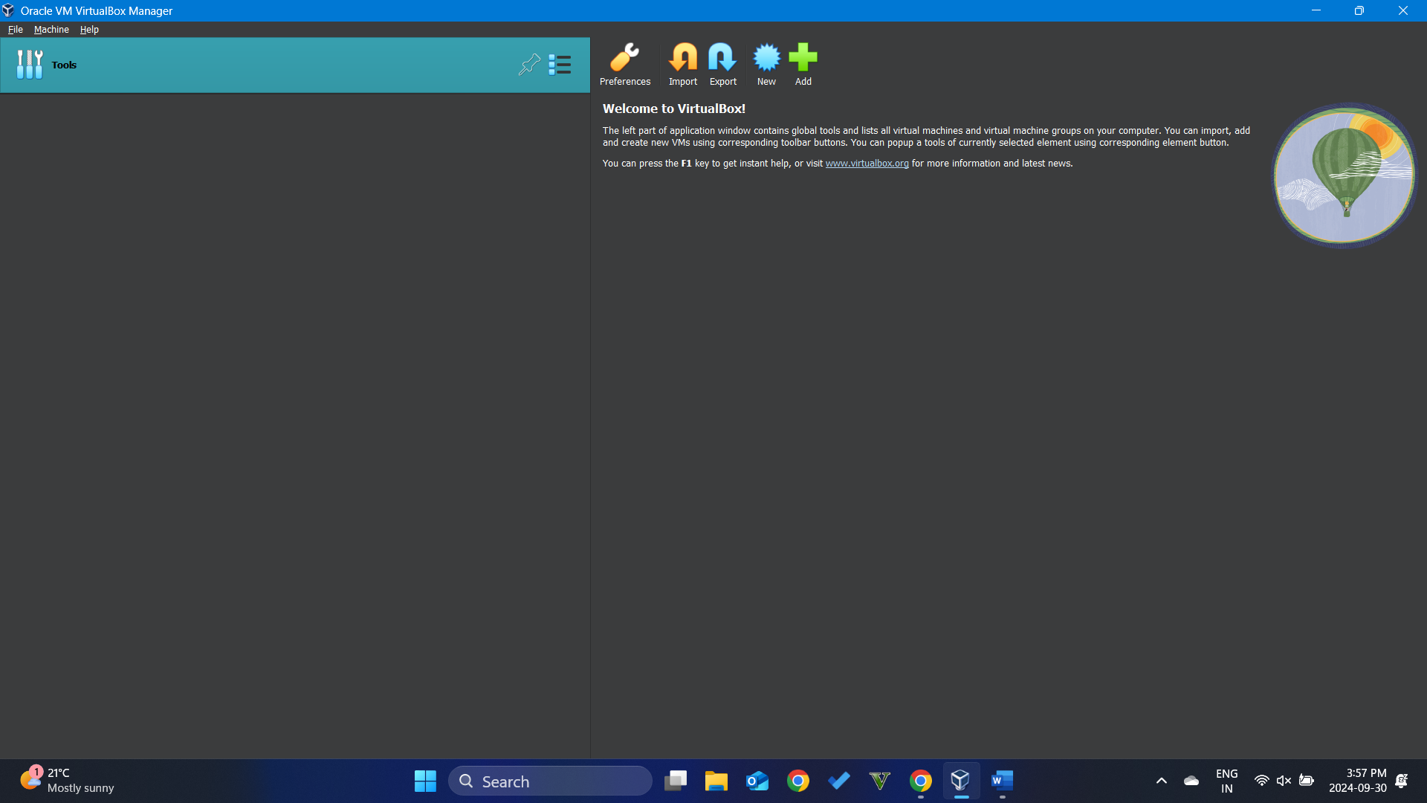
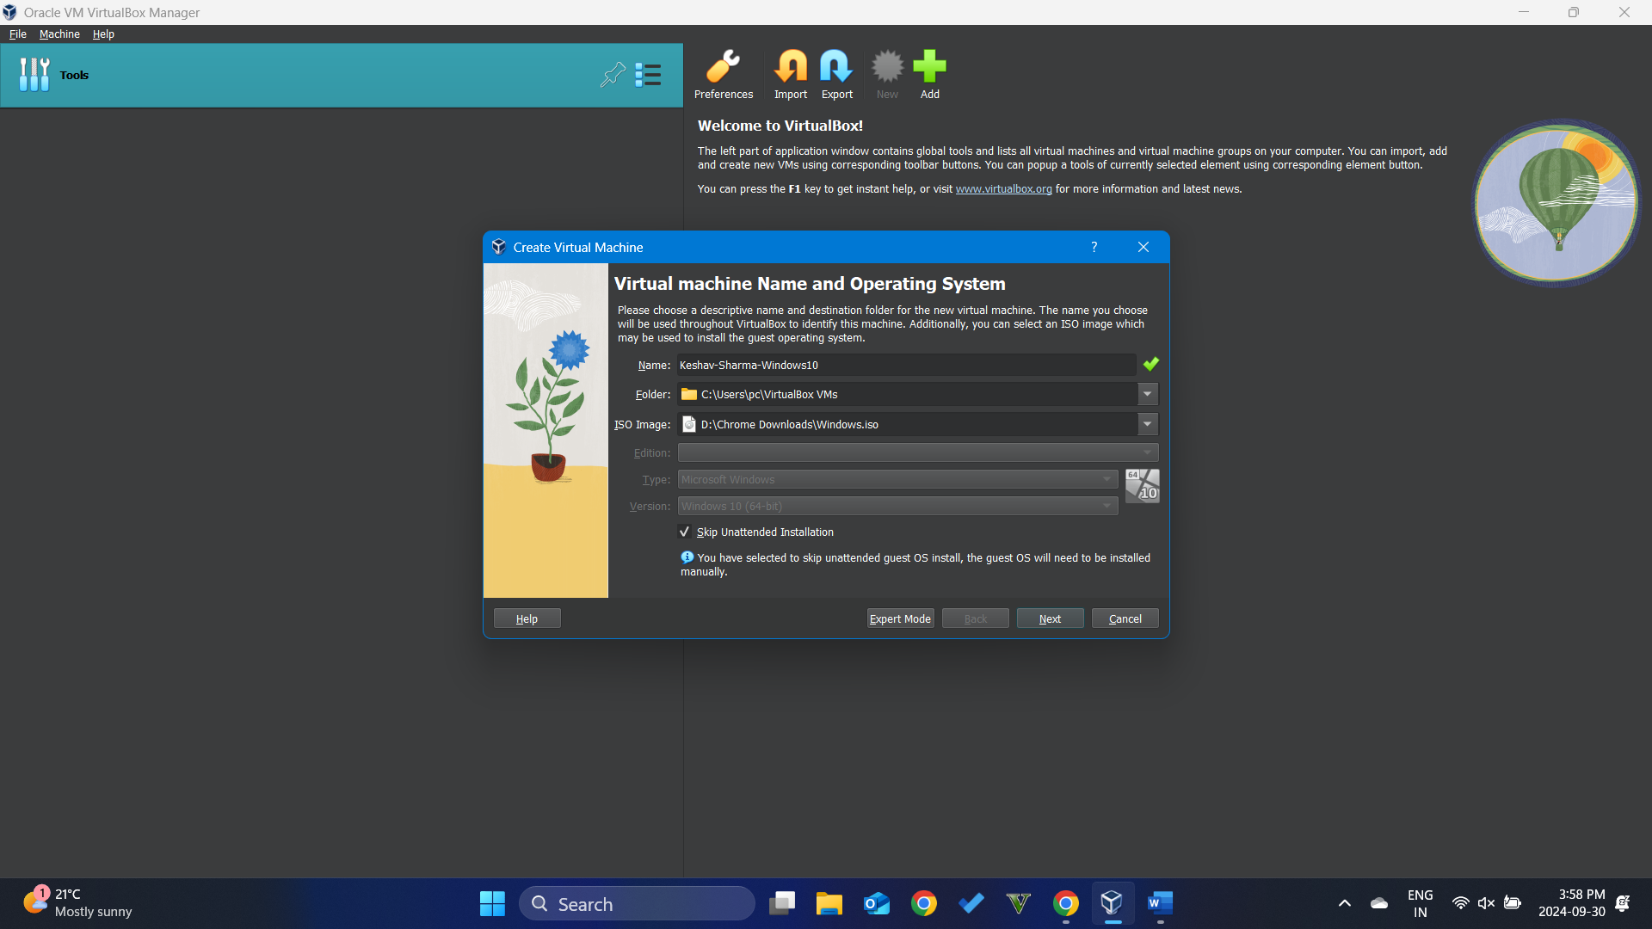
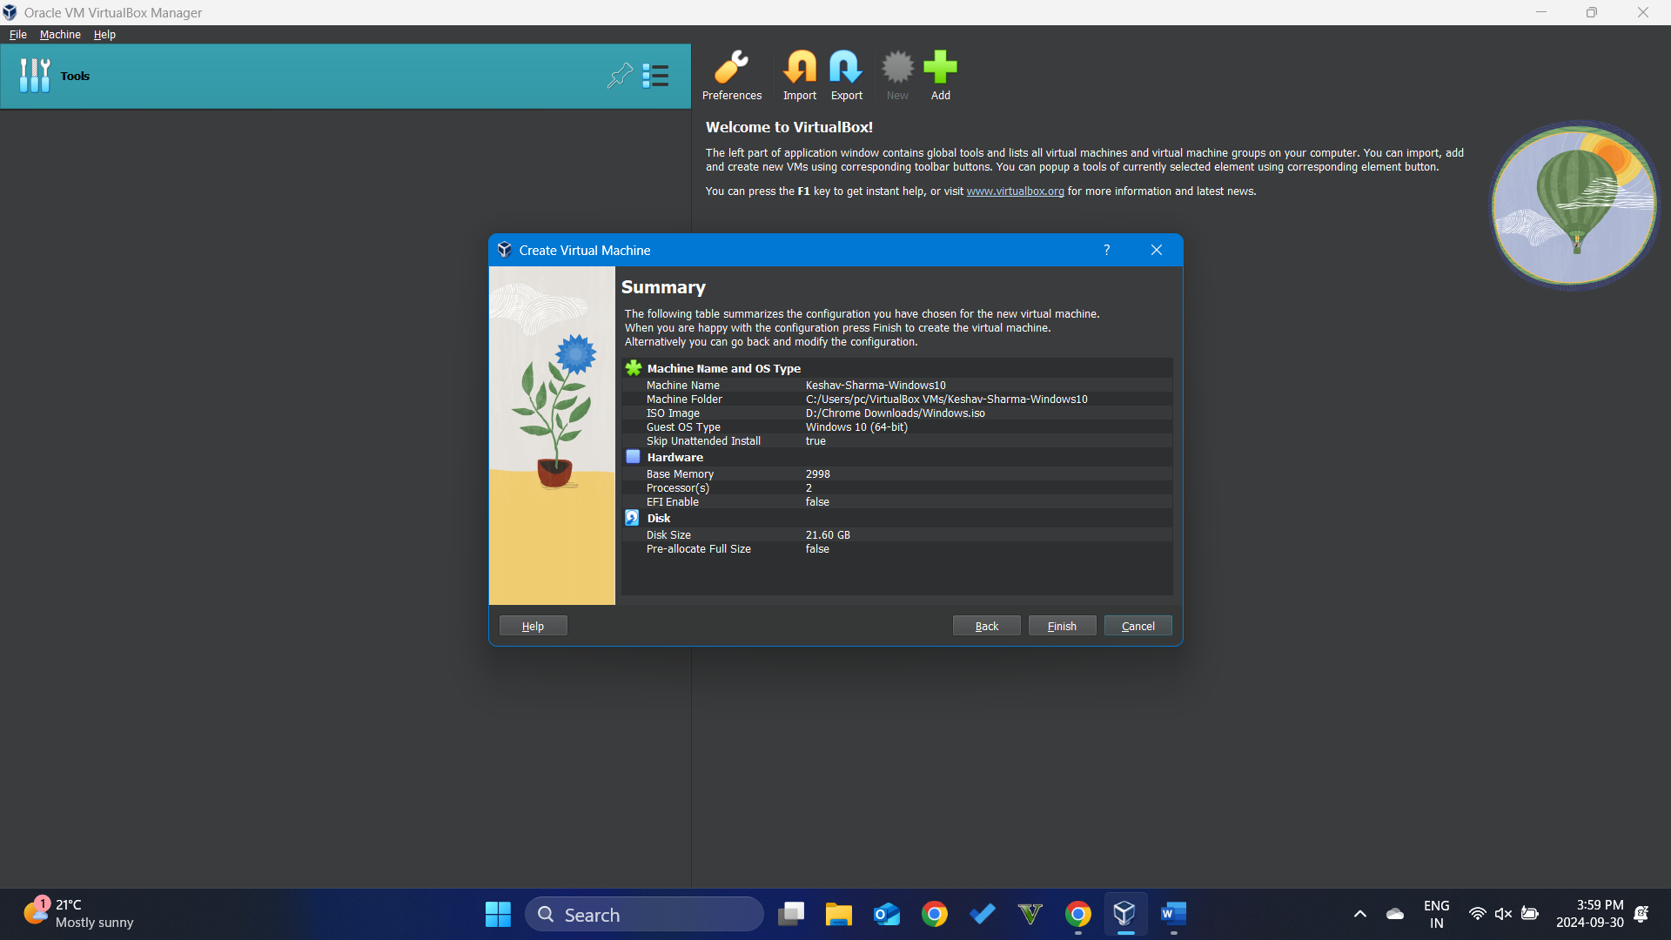
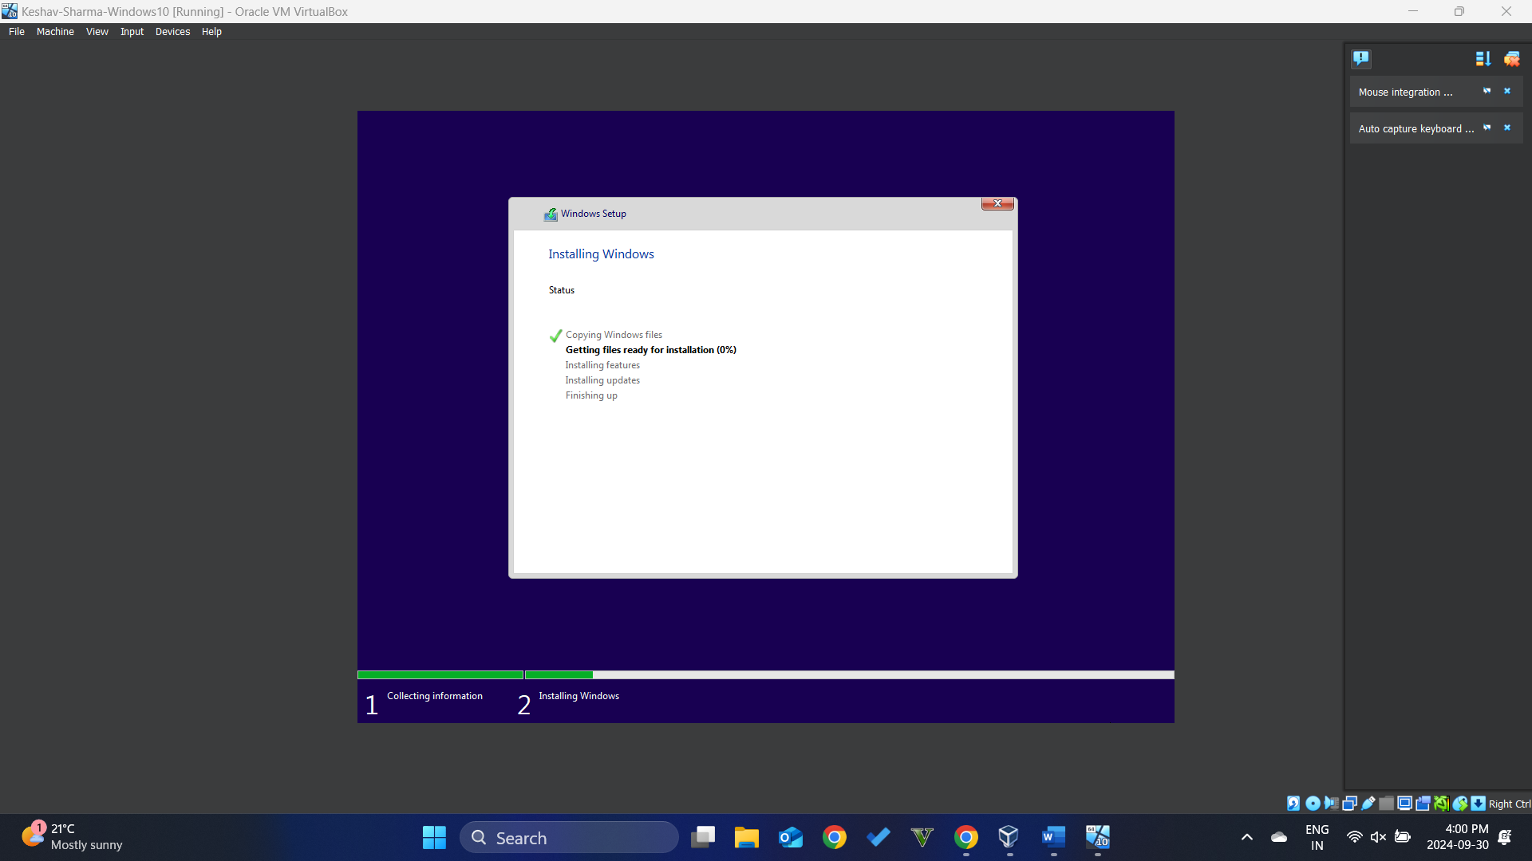

Google the Netcraft add-on for Internet Edge, Google Chrome and Firefox browsers
Netcraft
      - Google, download and install VMware student software.

Install the add-on Internet Edge
      - Go the the link that you find to install the extension
      - Click on Get and Add extention, you will find the notification that the extension has been added.
[Take a screenshot 01 of the output windows and paste it here]
Extension on the MICROSOFT EDGE WAS NOT WORKING and the screenshots for the CHROME WEB BROWSER AND MOZILLA FIREFOX is mentioned below
The screenshot 01 must show the evidence that the extension has been added successfully.

Repeat the steps 2 above with other browsers
      - Install just a new browser such as either Google Chrome or Firefox
      - Install the browser extension, and you will find the notification that the extension has been added.
[Take a screenshot 02 of the output windows and paste it here]

Netcraft Extension for the Chrome Web Browser 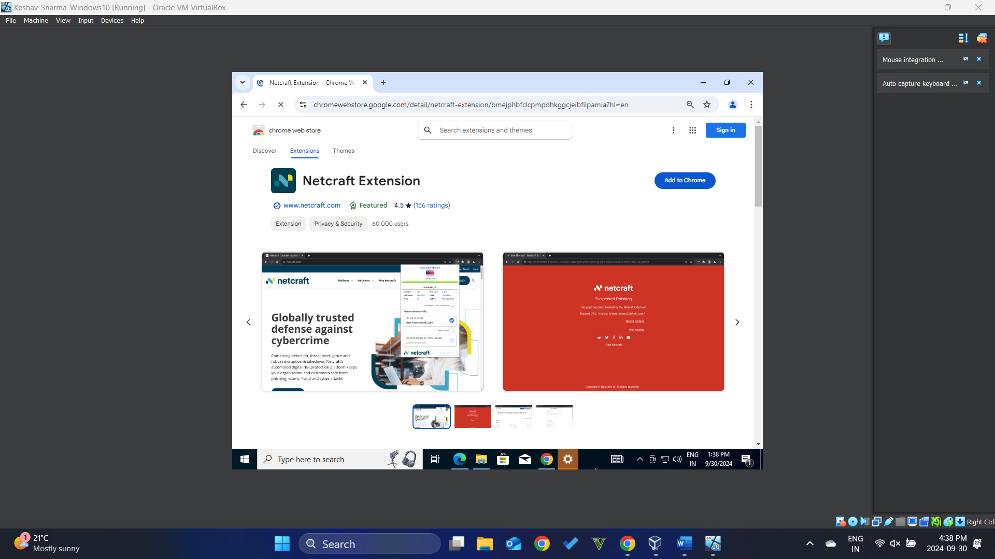
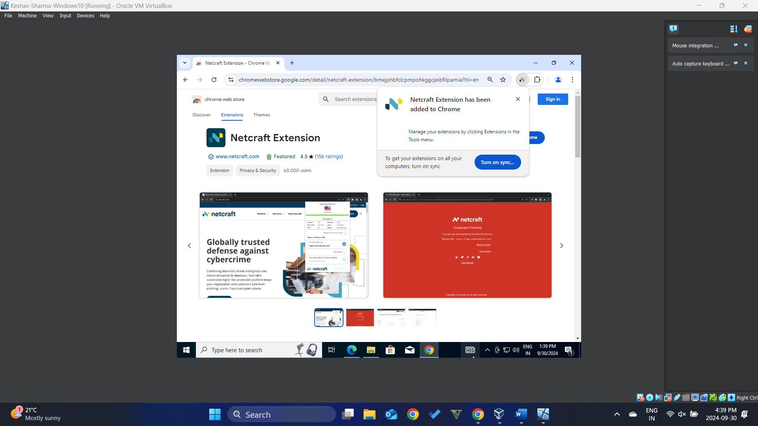

Net Craft Extension for the Mozilla Firefox
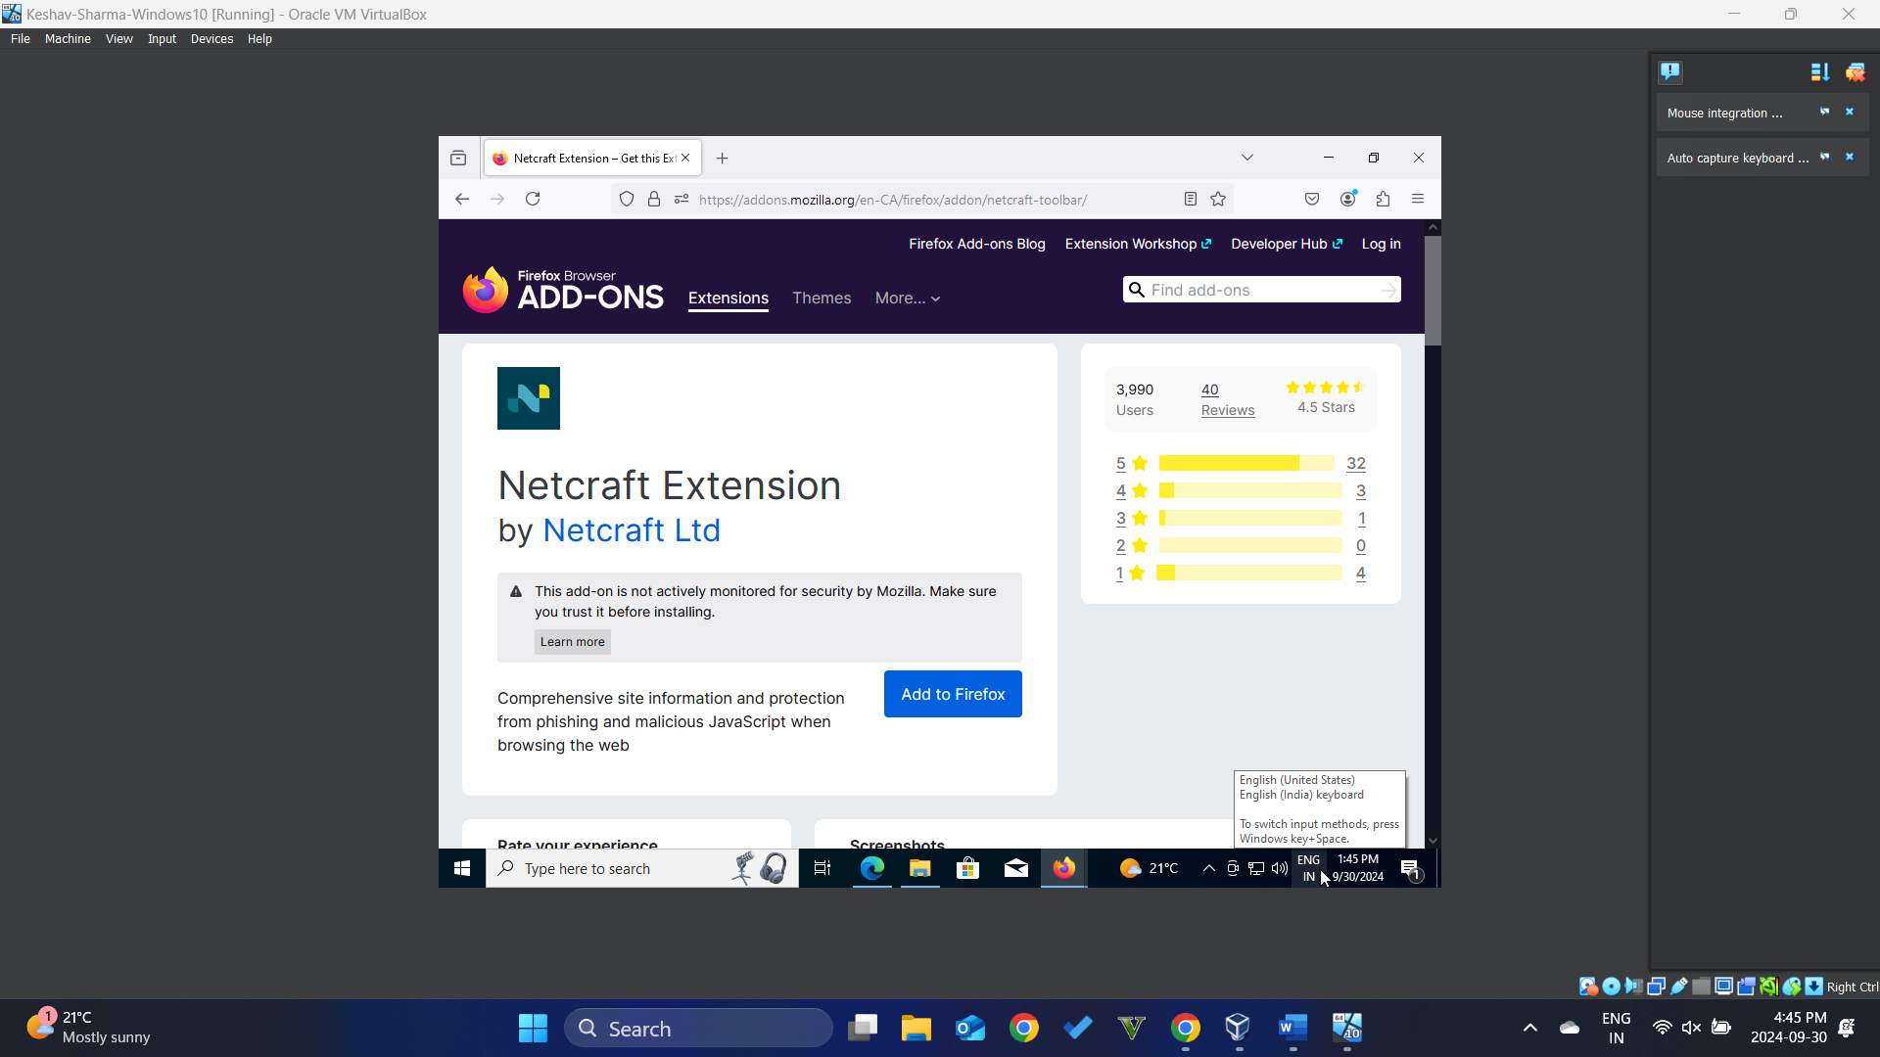
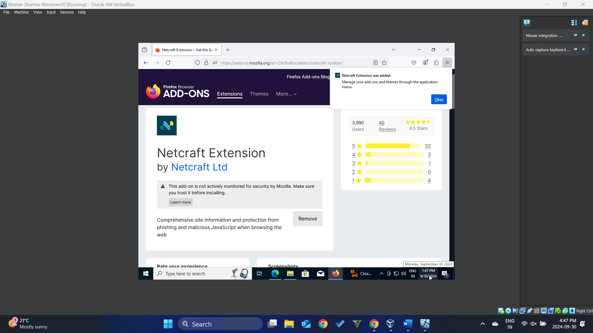
The screenshot 02 must show the evidence that the extension has been added successfully.

Detect the phishing sites
      - Open the web browser and access some phishing site
https://www.examp1eb4nk.com
[Take a screenshot 03 of the output windows and paste it here]

Screenshot of the Chrome Web Browser
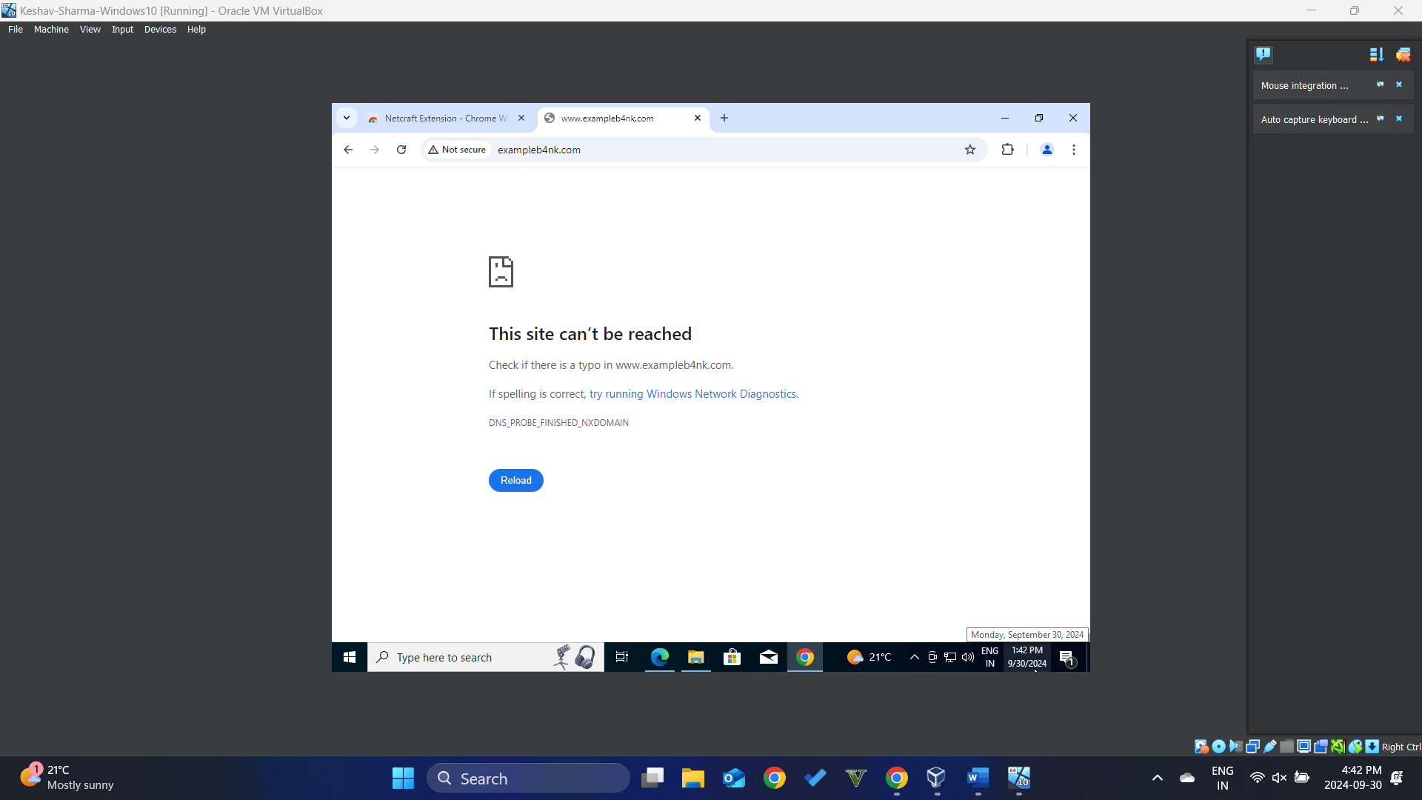
Screenshot of the Mozilla Firefox Browser
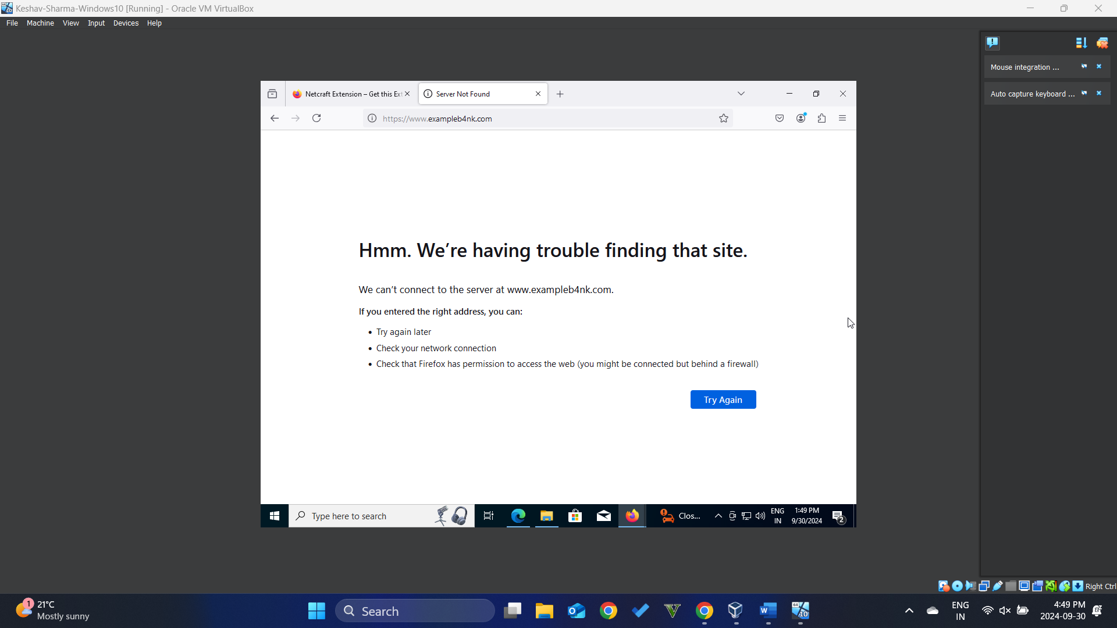

The screenshot 03 to validate whether the security add-on extension work or not

Reflection question
      - What do you think about the link whether it is malicious or not? And why?
[Reflection question 01: Write your answer 01 here]
Yes, The Site is malicious because Netcraft Extension installed in the Chrome web browser and Mozilla Firefox does not allow the browser to load the phishing sites and as mentioned in the screenshots the site is unreachable as it is a malicious site.

Lab 1.2 – Network scanning tools

Objectives
Part 1: Prepare a Computer for Virtualization
Part 2: Import the VM
Part 3: Password Dictionary attack

Required Resources
- A VM for Windows client with a minimum of CPU 1 core, 4 GB of RAM and 12 GB of free disk space.
- VMware Workstation Player, Oracle VirtualBox or any other software that meet NCT policy and your own convenience.

Instructions

Prepare a VM Windows 10 with scanning tool

Download and install the zenmap scanning tool
Zenmap is GUI version of nmap that instructor did the live scanning demonstration.
      - Make sure the host OS has Internet access
      - Change the guest OS (Windows 10) network settings
Go to Virtual box Manager – Virtual Machine Setting – Network Adapter – and change the network setting to VMnet8 (NAT)
[Take a screenshot 04 of the output windows and paste it here]
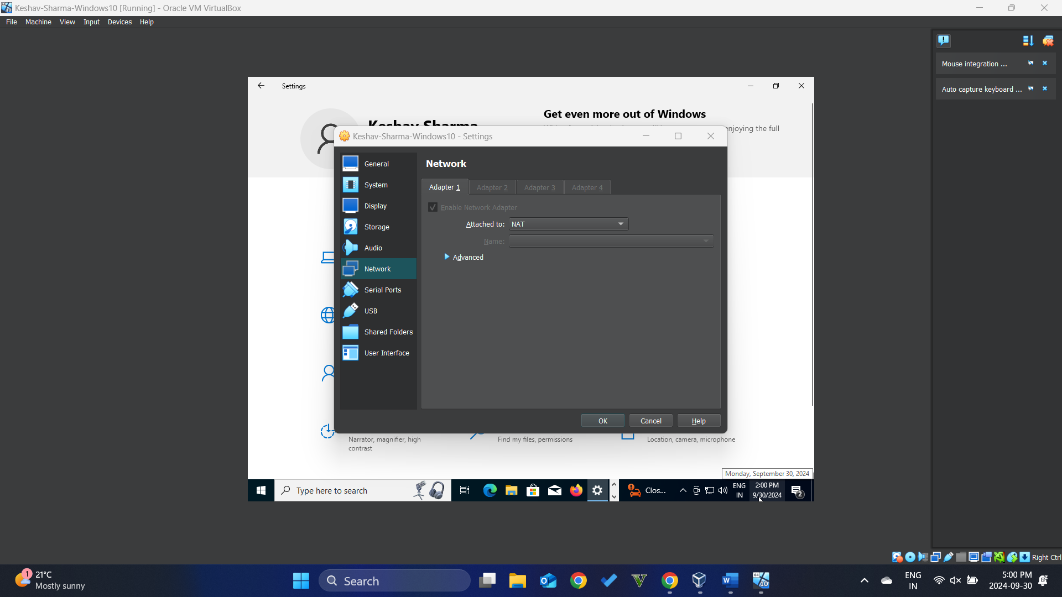
Click on OK
Validate Internet connection by ICMP to 8.8.8.8
      - Google Zenmap software, download and then install it
Download the Free Nmap Security Scanner for Linux/Mac/Windows
During Zenmap installation, you also need to install packet capture software pcap
      - After successfully installing, open the Zenmap software.
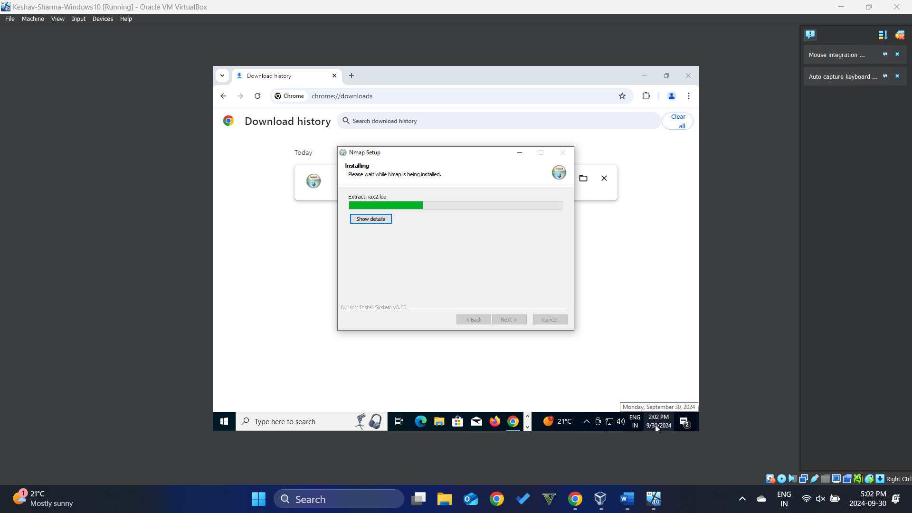
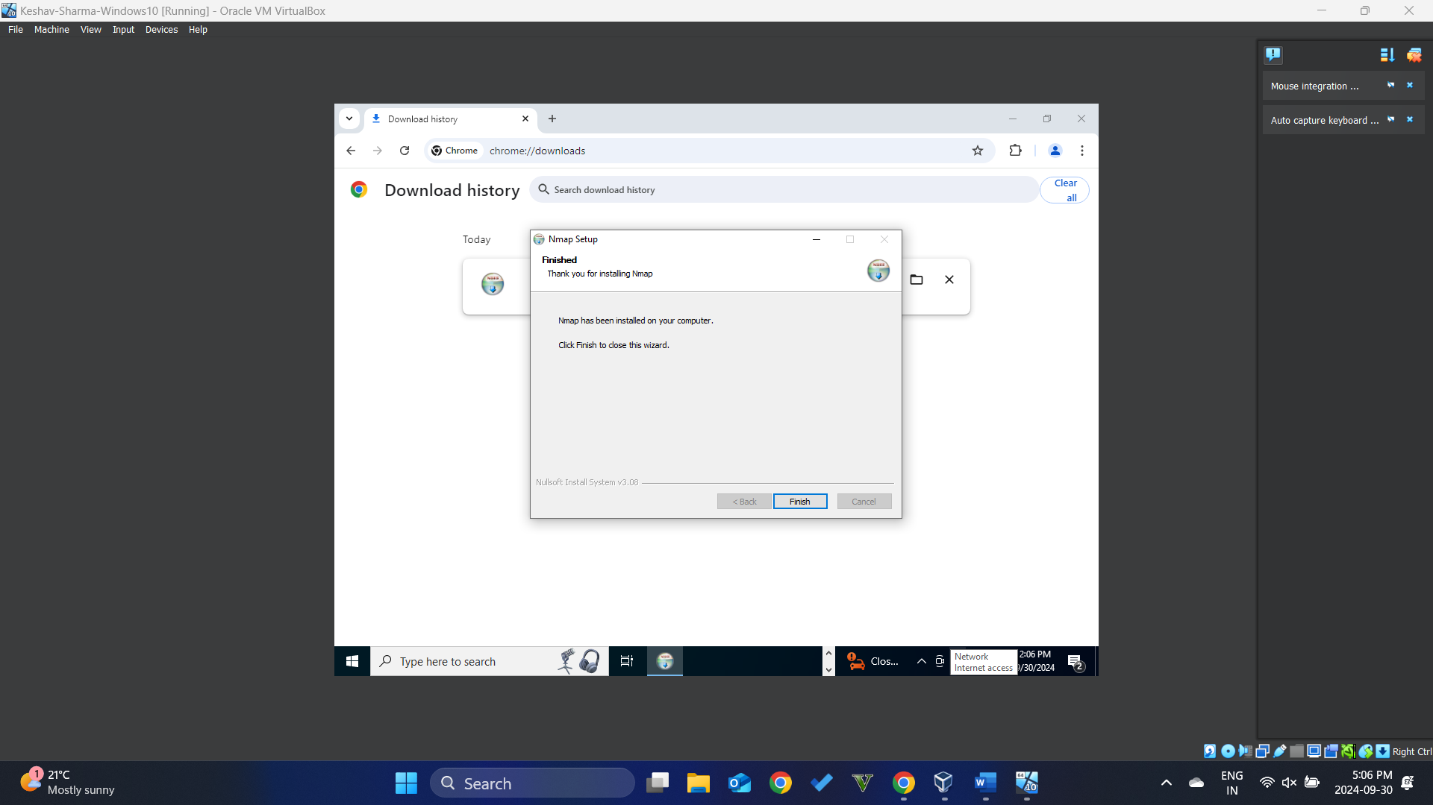
[Take a screenshot 05 of the output windows and paste it here]

Find out the target to scan
This lab, the students will scan the Windows 10 itself to collect and discover necessary information about Windows 10 VM and also the services are running on it
      - Open the cli and find out the IP address
      - What is the IP address, subnet mask, default gateway and dns information?
IP address is: [10.0.2.15]
[Take a screenshot 06 of the output windows and paste it here]
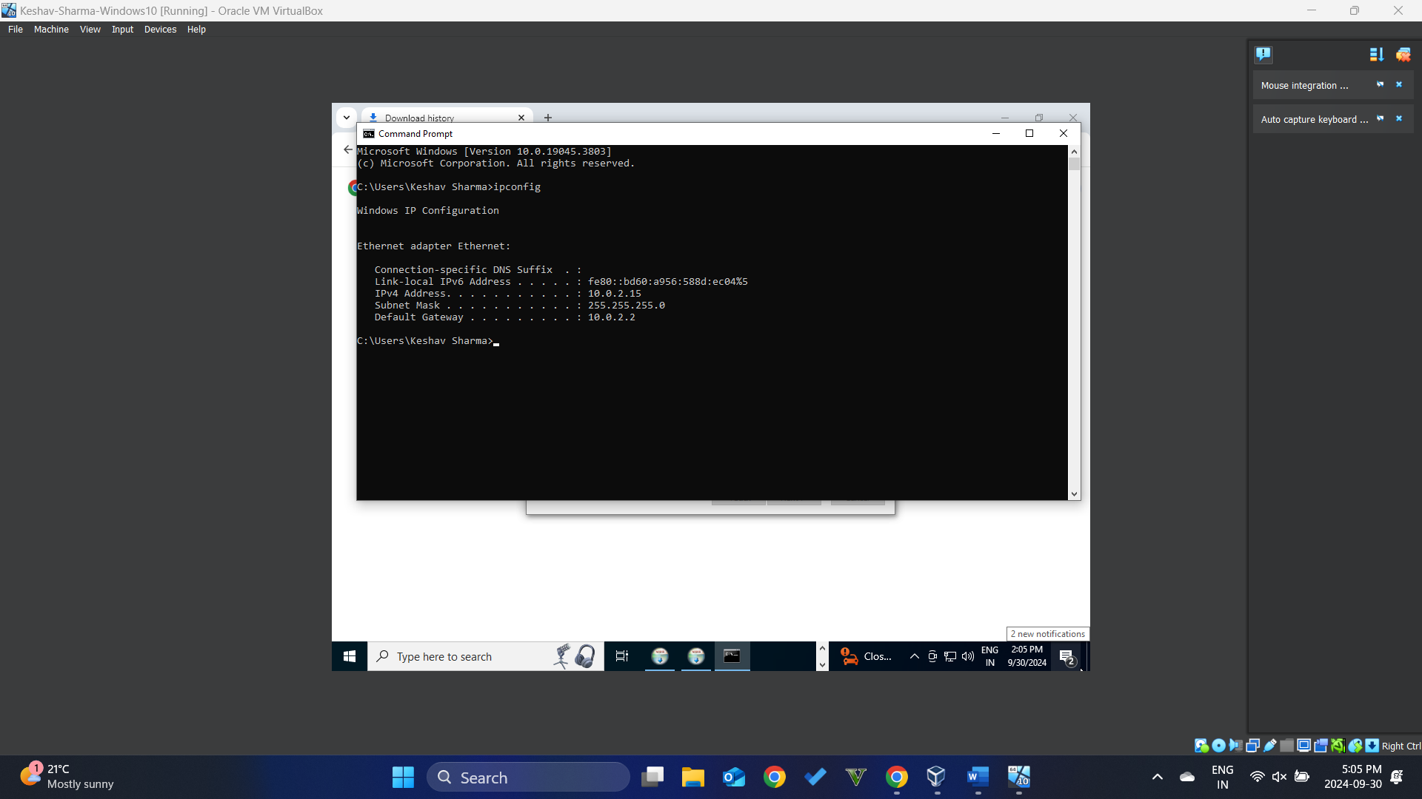
The screenshot 06 must show the evidence that the IP address info is correct

Performing the scanning
      - Open Zenmap software
You will see the boxes: Target:, Profile:, and Command:, and action Scan
      - In Target box, enter the IP address of Windows 10
In Profile box, choose Intense scan to Scan
You will find the list of PORT, STATE, SERVICE and VERSION is opening on Windows target host
The list of opening ports are:
135/TCP open msrpc Microsoft Windows RPC
139/TCP open netbios-ssn Microsoft Windows netbios-ssn
445/TCP open microsoft-ds?
[Take a screenshot 07 of the output windows and paste it here]
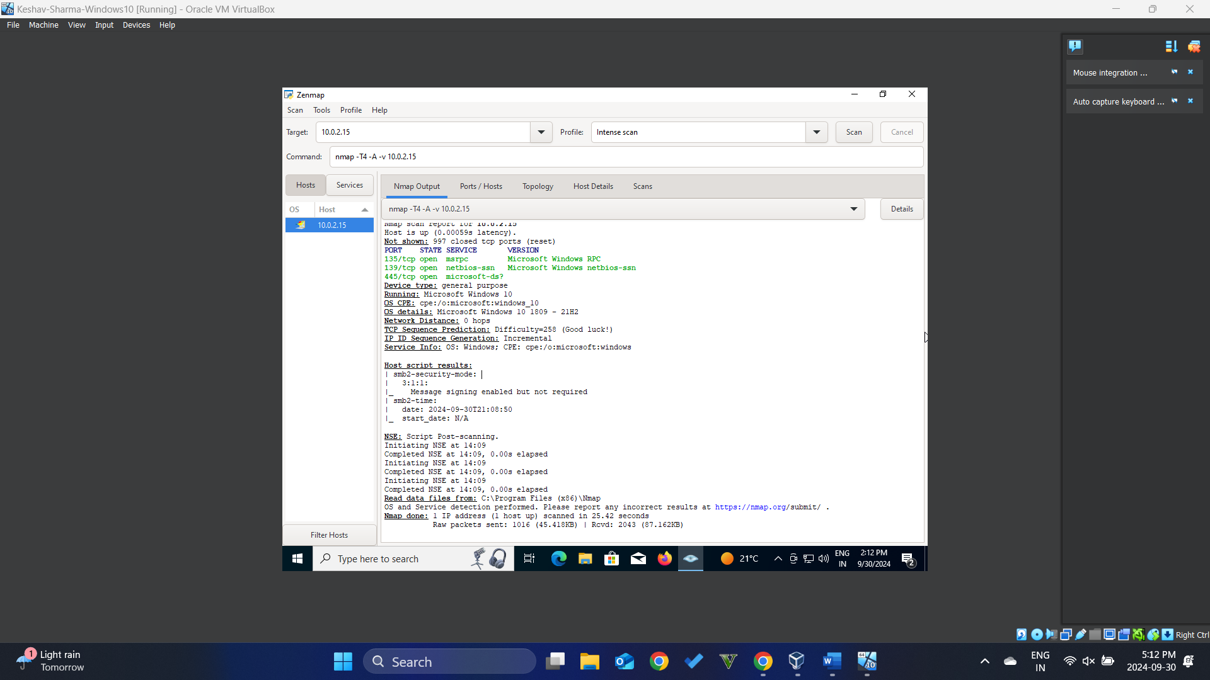
The screenshot 07 must show the evidence that the list of opening ports is correct

Find out the way to scan the OS information

Find out the option in nmap command to discover the OS info
      - Go to the box Command and type nmap -help
      - Examine carefully the output result to see which option to detect the OS info
      - What is the option in nmap command to dectect the OS info
[Reflection question 02:
-o: Enable OS detection
--osscan-limit: Limit OS detection to promising targets
--osscan-guess: Guess OS more agressively

Perform the scanning that detect the OS info
Based on the information and the answer for Reflection question 2 above, students perform the scanning
The command uses to perform the OS scanning on Windows 10 host target is: [--osscan-limit: Limit OS detection to promising targets]
      - Go to the box Command and issue the command
      - What is the OS information you obtain via the scanning
The OS inforamtion is: [Microsoft Windows 10 1809-21H2]
[Take a screenshot 08 of the output windows and paste it here]
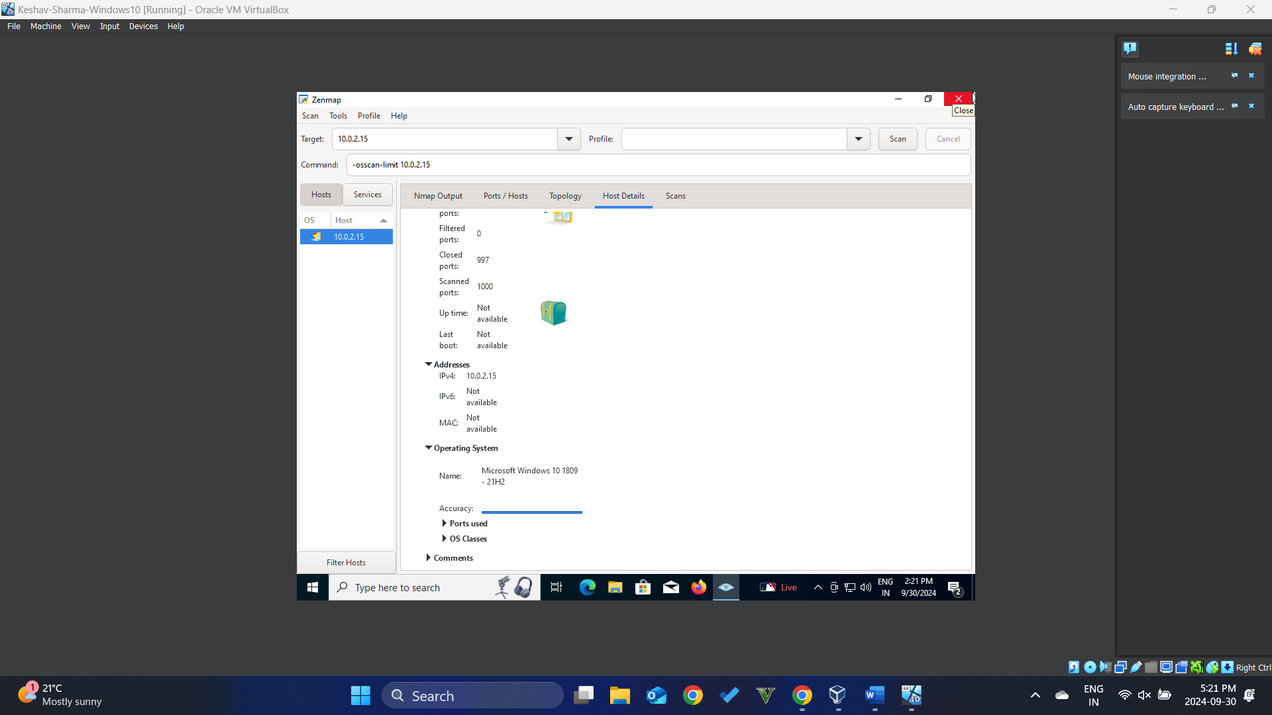
The screenshot 08 must show the evidence that the OS information is correct
your answers here.
Acknowledgement:
My name is ………Keshav Sharma (4532854) ……………………………………………………………………
I understand the lab rules and grading point calculation and I will strictly follow it.
Signature: …KESHAVSHARMA……………………. Date:………2024-09-30………

End of Document

